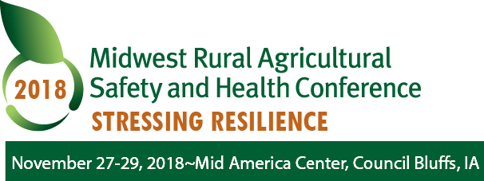

Sponsor and Exhibitor Opportunities

Gold Level ($3000 or more)
- Acknowledgement at the conference as a major sponsor
- Logo and link to sponsor’s website from MRASH website
- Recognition in program materials & to over 3000 Alive and Well newsletter readers
- Inclusion of one brochure in registrant packet
- Complimentary invitation for three to attend conference
- Complimentary display table and priority placement

Silver Level ($1500-$2999)
- Acknowledgement at the conference
- Recognition on website, program materials, & to over 3000 Alive &Well newsletter readers
- Inclusion of one brochure in registrant packet
- Complimentary invitation for two to attend conference
- Complimentary display table and priority placement

Bronze Level ($1000-$1499)
- Recognition on website & program materials
- Inclusion of one brochure in registrant packet
- Complimentary invitation for two to attend conference
- Complimentary display table at event

Commercial Exhibitor ($500 - $999)
- Recognition on MRASH website program materials and in program materials
- Complimentary invitation for one to attend the conference
- Complimentary display table at the event

Non-Profit Exhibitor ($250 or more)
- Recognition in program materials and on MRASH website
- Complimentary invitation for one to attend the conference
- Complimentary display table at the event

2018 Sponsorship and Exhibitor Form
Company/Organization Name:
Contact Name
E-mail
Phone
Fax
Address
City, State, Zip
Sponsorship Level : | Gold (≥$3000) Silver ($1500-$2999) Bronze ($1000-$1499)
Exhibitor Level: | Commercial Exhibit ($500-$999) Non-profit Exhibit (≥$250)
Display table needed? | yes no
Handouts for conference packet? | yes no

Who will attend the conference under your invitation? Please note: they should still complete a full conference registration form from our conference website at www.i-cash.org/2018-MRASH, check the “Pay Later” option and the names listed below will be credited a complimentary registration.
Names & emails of those attending:
1st Participant (Exhibitor Or Sponsor Levels)_____________________________________________
2nd Participant (Bronze, Silver, Gold Levels only) ________________________________________
3rd Participant (Gold Level only) ______________________________________________________

Payment:
- Check enclosed: Checks should be made payable to: Center for Conferences and Institutes.
Mail to the address provided below
or
- Visa or Mastercard payment can be accepted. Amount: __________________________
/__/__/__/__/__/__/__/__/__/__/__/__/__/__/__/__/ expires:__ __/__ __ 3 digit security code: __/__/__/
Cardholder Name _________________________________________________________________________
Cardholder Billing Address (including street, city, state, and zip)
________________________________________________________________________________________
________________________________________________________________________________________
Please return this form via fax to (319) 335-4039 or by mail:
Center for Conferences and Institutes, Attn: Kelly Flinn
250 Continuing Education Facility
Iowa City, Iowa 52242-0907
If you have any questions, contact The Center for Conferences at (319) 335-4141 or conferences@uiowa.edu

