ANHYDROUS AMMONIA SAFETY TRAINING

Thursday November 29, 2018 –1:00-2:30 pm

Mid-America Center, Council Bluffs IA

Dan Neenan from the National Education Center for Agricultural Safety (NECAS) will demonstrate safety practices using a training simulator and discuss:
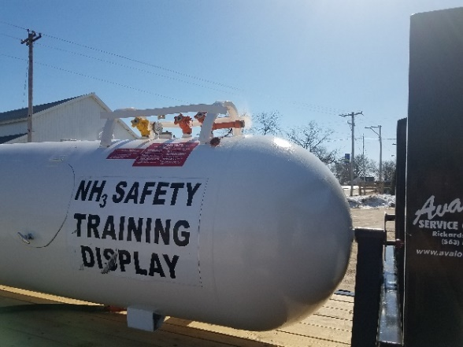
- Construction features of an anhydrous ammonia nurse tank
- Nurse tank valves and shutoffs
- Hazards associated with nurse tank ruptures
- Haz-Com Standard
- Choosing correct PPE (Personal Protective Equipment)

Join us for lunch at 12:00 pm, Cost $10

To register or for more info:
visit www.i-cash.org/2018.mrash
or call 800-551-9029

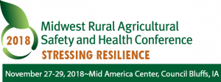
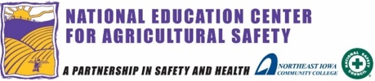
Training Sponsored By:

