**Messaging in Minutes**

**Visual Accessibility-**Marsha Cheyney, University of Iowa

* Why accessibility?
* Accessible graphic design not only helps people with disabilities navigate sites and understand the visual content independently, but it also makes them feel included and valued.
* Compliance with guidelines and standards: [Web Content Accessibility Guidelines (WCAG)](https://www.continualengine.com/blog/ensuring-web-accessibility/) and the Accessible Ion Project
* Reach more people on a wide variety of devices – and they understand it better
* Use of color contrast, and texture
  + Contrast ratio (between text and background) – no rounding allowed!
  + Brightness, saturation, and hue analysis – avoid overly intense colors and create balanced palette
  + Responsive design - ensures that the contrast is maintained on different devices and environments.
  + Use texture in graphics – never rely solely on color to relay information
* Alt text for images - Screen readers read this description in place of images (for visually impaired, cognitive disabilities)
  + Also used if browser can’t display image (due to browser incompatibility or other tech issues)
  + Improves search engine optimization (SEO) – google finds your page faster
  + The **alt** attribute should:
    - be accurate and equivalent in representing content and function (why you included that particular image/graph. Can be blank if image does not relay relevant or important information)
    - be succinct. Content (if any) and function (if any) should be presented as succinctly as possible, without sacrificing accuracy.
    - not be redundant or provide the same information as text near the image.
    - not include phrases like "image of ..." or "graphic of ...", etc. This would be redundant since screen readers already announce "graphic" along with the alt text. If the fact that an image is a photograph or illustration, etc. is important content, it may be useful to include this in alternative text.
* Using descriptive captions – for those who are less chart/graph literate, or need assistance in finding what is important in a photo/illustration (slow processors). It is very helpful to tell how the chart/graph is interpreted, not just what the axes represent.
* 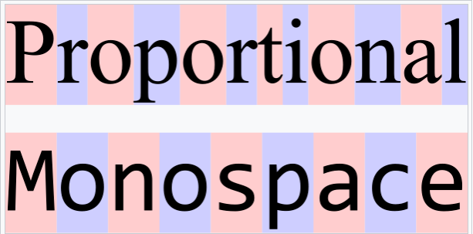Fonts and line spacing
  + Readable at different sizes – user can adjust as needed
  + Monospace sans serif fonts are best (see image to right)
  + Enough space between lines to read easily, but not so much that it is hard to follow (1.5-2x font size)
  + Choose a medium line length to optimize readability
* Embedded text in graphics –
  + needs to be pulled out and added to descriptions –
  + includes legends for maps or charts/graphs
* Doing accessibility checks –
  + We aren’t perfect, even when we know what to do – new “eyes” to look at content
  + Guidelines and standards change – keeps you current
* Doing readability/reading level checks –
  + Used to say write at 8th grade level – now they say 4-6th grade level for health related information
  + We are generally **not** good at this
  + Paste text in, get readability score(s)
  + Hemingway, Readability Formulas, Originality AI, WebFX – so many tools, google it

Resources:

* **Web Content Accessibility Guidelines (WCAG 2.2)** - <https://www.boia.org/wcag-2.2aa-checklist>
* **WebAIM Contrast Checker**: <https://webaim.org/resources/contrastchecker/>
  + Enter hex value to check contrast between 2 colors
  + This site also gives a lot of information on WCAG and WCAG2
* **Poet Training Tool**: <https://poet.diagramcenter.org/>
  + Training on when and how to describe a variety of image types.
* **Funkify**: <https://www.funkify.org/>
  + Disability simulator with “personalities”– dyslexia, cognition, motor, visual
  + Chrome extension – free or $5/mo
* **WAVE Web Accessibility Evaluation Tools -** <https://wave.webaim.org/>
  + Evaluates webpages for accessibility, gives impact report
* **Hemingway Editor App -** hemingwayapp.com/
  + Checks reading level, identifies issues that make your writing less clear: wordy sentences, passive voice, words with simpler alternatives, etc)
  + Desktop ($20) (no AI) and App
  + Paid app with AI is $100-150/year
* **Readability Formulas -** ReadabilityFormulas.com
  + Free text readability consensus calculator and a separate readability tool to calculate grade levels using formulas like Dale-Chall formula, Spache formula, Fry graph, etc
  + Looks like it comes from the 90’s, but has a lot of different formulas it uses
* **Originality.AI Readability Checker -** <https://originality.ai/readability-checker>
  + Availability as web-based tool and browser extension
  + Detects plagiarism and AI writing in addition to reading level
* **WebFX Readability Test Tool**
  + Enter URL and it analyzes (or enter text directly)
  + Several readability formulas
  + Explains readability scores